[Skip to main content](http://www.rajalakshmicolleges.org/moodle/mod/quiz/review.php#maincontent)

REC-CIS

GE23131-Programming Using C-2024

|  |  |
| --- | --- |
| **Status** | Finished |
| **Started** | Saturday, 11 January 2024, 5:32 PM |
| **Completed** | Saturday, 11 January 2025, 5:51 PM |
| **Duration** | 19 mins 8 secs |

Top of Form

Question **1**

Correct

Marked out of 1.00

Flag question

Question text

Given a string, ***s***, consisting of alphabets and digits, find the frequency of each digit in the given string.

**Input Format**

The first line contains a string, ***num***which is the given number.

**Constraints**

***1 ≤ len(num) ≤ 1000***

All the elements of num are made of English alphabets and digits.

**Output Format**

Print ten space-separated integers in a single line denoting the frequency of each digit from ***0*** to ***9***.

**Sample Input 0**

a11472o5t6

**Sample Output 0**

0 2 1 0 1 1 1 1 0 0

**Explanation 0**

In the given string:

·         ***1*** occurs two times.

·         ***2, 4, 5, 6*** and ***7*** occur one time each.

The remaining digits ***0, 3, 8*** and ***9*** don't occur at all.

Answer:(penalty regime: 0 %)

Feedback

|  | **Input** | **Expected** | **Got** |  |
| --- | --- | --- | --- | --- |
|  | a11472o5t6 | 0 2 1 0 1 1 1 1 0 0 | 0 2 1 0 1 1 1 1 0 0 |  |
|  | lw4n88j12n1 | 0 2 1 0 1 0 0 0 2 0 | 0 2 1 0 1 0 0 0 2 0 |  |
|  | 1v88886l256338ar0ekk | 1 1 1 2 0 1 2 0 5 0 | 1 1 1 2 0 1 2 0 5 0 |  |

Passed all tests!

Question **2**

Correct

Marked out of 1.00

Flag question

Question text

Today, Monk went for a walk in a garden. There are many trees in the garden and each tree has an English alphabet on it. While Monk was walking, he noticed that all trees with vowels on it are not in good state. He decided to take care of them. So, he asked you to tell him the count of such trees in the garden.

**Note**: The following letters are vowels: 'A', 'E', 'I', 'O', 'U', 'a', 'e', 'i', 'o' and 'u'.

**Input**:

The first line consists of an integer *T* denoting the number of test cases.

Each test case consists of only one string, each character of string denoting the alphabet (may be lowercase or uppercase) on a tree in the garden.

**Output**:

For each test case, print the count in a new line.

**Constraints**:

***1 ≤ T ≤ 10  
1 ≤ length of string ≤ 105***

**SAMPLE INPUT**

2

nBBZLaosnm

JHkIsnZtTL

**SAMPLE OUTPUT**

2

1

**Explanation**

In test case 1, a and o are the only vowels. So, count=2

Answer:(penalty regime: 0 %)

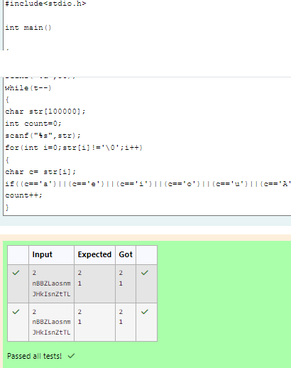

Feedback

|  | **Input** | **Expected** | **Got** |  |
| --- | --- | --- | --- | --- |
|  | 2  nBBZLaosnm  JHkIsnZtTL | 2  1 | 2  1 |  |
|  | 2  nBBZLaosnm  JHkIsnZtTL | 2  1 | 2  1 |  |

Passed all tests!

Question **3**

Correct

Marked out of 1.00

Flag question

Question text

Given a sentence, ***s***, print each word of the sentence in a new line.

**Input Format**

The first and only line contains a sentence, ***s***.

**Constraints**

***1 ≤ len(s) ≤ 1000***

**Output Format**

Print each word of the sentence in a new line.

**Sample Input 0**

This is C

**Sample Output 0**

This

is

C

**Explanation 0**

In the given string, there are three words ["This", "is", "C"]. We have to print each of these words in a new line.

Answer:(penalty regime: 0 %)

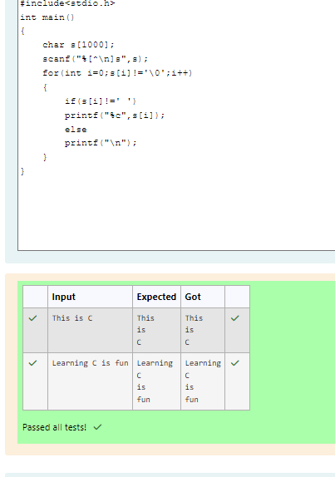

Feedback

|  | **Input** | **Expected** | **Got** |  |
| --- | --- | --- | --- | --- |
|  | This is C | This  is  C | This  is  C |  |
|  | Learning C is fun | Learning  C  is  fun | Learning  C  is  fun |  |

Passed all tests!

Question **4**

Correct

Marked out of 1.00

Flag question

Question text

**Input Format**

You are given two strings, ***a*** and ***b***, separated by a new line. Each string will consist of lower case Latin characters ('a'-'z').

**Output Format**

In the first line print two space-separated integers, representing the length of ***a*** and ***b*** respectively.

In the second line print the string produced by concatenating ***a*** and ***b*** (***a + b***).

In the third line print two strings separated by a space, ***a'*** and ***b'***. ***a'*** and ***b'*** are the same as***a***and ***b***, respectively, except that their first characters are swapped.

**Sample Input**

abcd

ef

**Sample Output**

4 2

abcdef

ebcd af

**Explanation**

a = "abcd"

b = "ef"

|a| = 4

|b| = 2

a + b = "abcdef"

a' = "ebcd"

b' = "af"

Answer:(penalty regime: 0 %)

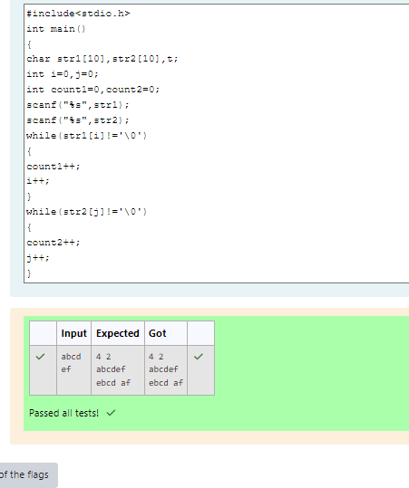

Feedback

|  | **Input** | **Expected** | **Got** |  |
| --- | --- | --- | --- | --- |
|  | abcd  ef | 4 2  abcdef  ebcd af | 4 2  abcdef  ebcd af |  |

Passed all tests!

Bottom of Form

Blocks

[Skip Quiz navigation](http://www.rajalakshmicolleges.org/moodle/mod/quiz/review.php#sb-1)

Quiz navigation

[Question1This page](http://www.rajalakshmicolleges.org/moodle/mod/quiz/review.php#question-135783-1)[Question2This page](http://www.rajalakshmicolleges.org/moodle/mod/quiz/review.php#question-135783-2)[Question3This page](http://www.rajalakshmicolleges.org/moodle/mod/quiz/review.php#question-135783-3)[Question4This page](http://www.rajalakshmicolleges.org/moodle/mod/quiz/review.php#question-135783-4)

[Show one page at a time](http://www.rajalakshmicolleges.org/moodle/mod/quiz/review.php?attempt=135632&cmid=191&showall=0)

Blocks